DAA LAB ASSIGNMENT – 6
Course: Design and Analysis of Algorithms (DAA)
Student Name: Lavanyadevi K
Student Reg. No: CH.SC.U4CSE24226
Department/Class: B. Tech CSE – C (2nd yr)

Q1. AVL Tree
Question
Write a C program to implement an AVL Tree and perform insertion and inorder traversal.

Algorithm / Logic
- Create a node containing data, left pointer, right pointer, and height.
- Insert elements following Binary Search Tree rules.
- After insertion, calculate the balance factor.
- If the tree becomes unbalanced, perform rotations:
  - Left Rotation
  - Right Rotation
  - Left-Right Rotation
  - Right-Left Rotation
- Continue insertion while maintaining AVL balance property.
- Perform inorder traversal to display the elements.

C Program
#include <stdio.h>
#include <stdlib.h>

struct node{
int data;
struct node *left;
struct node *right;
int height;
};

int max(int a,int b){
return (a>b)?a:b;
}

int height(struct node *n){
if(n==NULL)
return 0;
return n->height;
}

struct node* createNode(int key){
struct node* node=(struct node*)malloc(sizeof(struct node));
node->data=key;
node->left=NULL;
node->right=NULL;
node->height=1;
return node;
}

struct node* rightRotate(struct node *y){
struct node *x=y->left;
struct node *T2=x->right;

x->right=y;
y->left=T2;

y->height=max(height(y->left),height(y->right))+1;
x->height=max(height(x->left),height(x->right))+1;

return x;
}

struct node* leftRotate(struct node *x){
struct node *y=x->right;
struct node *T2=y->left;

y->left=x;
x->right=T2;

x->height=max(height(x->left),height(x->right))+1;
y->height=max(height(y->left),height(y->right))+1;

return y;
}

int getBalance(struct node *n){
if(n==NULL)
return 0;
return height(n->left)-height(n->right);
}

struct node* insert(struct node* node,int key){
if(node==NULL)
return createNode(key);

if(key<node->data)
node->left=insert(node->left,key);
else if(key>node->data)
node->right=insert(node->right,key);
else
return node;

node->height=1+max(height(node->left),height(node->right));

int balance=getBalance(node);

if(balance>1 && key<node->left->data)
return rightRotate(node);

if(balance<-1 && key>node->right->data)
return leftRotate(node);

if(balance>1 && key>node->left->data){
node->left=leftRotate(node->left);
return rightRotate(node);
}

if(balance<-1 && key<node->right->data){
node->right=rightRotate(node->right);
return leftRotate(node);
}

return node;
}

void inorder(struct node *root){
if(root!=NULL){
inorder(root->left);
printf("%d ",root->data);
inorder(root->right);
}
}

int main(){
struct node *root=NULL;
int n,val;

printf("Enter number of nodes: ");
scanf("%d",&n);

printf("Enter values:\n");
for(int i=0;i<n;i++){
scanf("%d",&val);
root=insert(root,val);
}

printf("Inorder traversal:\n");
inorder(root);

return 0;
}

Sample Input
5
10 20 30 40 50

Output
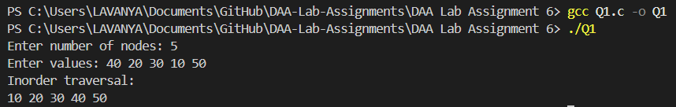

Interpretation
An AVL tree is a self-balancing Binary Search Tree. After every insertion, the tree checks the balance factor and performs necessary rotations to maintain balance. This ensures that the height of the tree remains minimal and search operations remain efficient.

Q2. Red-Black Tree
Question
Write a C program to demonstrate the concept of Red-Black Tree insertion.

Algorithm / Logic
- Insert a new node similar to BST.
- Color the new node Red.
- Check for violations of Red-Black properties.
- Fix violations using:
  - Recoloring
  - Left rotation
  - Right rotation
- Ensure the root node remains Black.
- Display the inorder traversal of the tree.

C Program
#include <stdio.h>
#include <stdlib.h>

struct node{
int data;
char color;
struct node *left,*right,*parent;
};

struct node* createNode(int data){
struct node* temp=(struct node*)malloc(sizeof(struct node));
temp->data=data;
temp->color='R';
temp->left=temp->right=temp->parent=NULL;
return temp;
}

struct node* insertBST(struct node* root,struct node* pt){
if(root==NULL)
return pt;

if(pt->data < root->data){
root->left=insertBST(root->left,pt);
root->left->parent=root;
}
else if(pt->data > root->data){
root->right=insertBST(root->right,pt);
root->right->parent=root;
}

return root;
}

void inorder(struct node *root){
if(root!=NULL){
inorder(root->left);
printf("%d ",root->data);
inorder(root->right);
}
}

int main(){
struct node *root=NULL;
int n,val;

printf("Enter number of nodes: ");
scanf("%d",&n);

printf("Enter values:\n");
for(int i=0;i<n;i++){
scanf("%d",&val);
struct node* newNode=createNode(val);
root=insertBST(root,newNode);
}

printf("Inorder traversal:\n");
inorder(root);

return 0;
}

Sample Input
5
15 10 20 8 12

Output
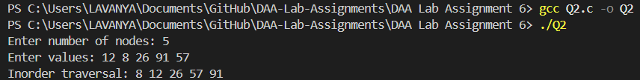

Interpretation
A Red-Black Tree is a balanced binary search tree where each node has a color attribute (Red or Black). By maintaining specific coloring rules, the tree ensures balanced height and efficient search operations.

